Y U V A I N T E R N

Virtual Data Science Explorer Internship

WEEK 1 TASK

Data Science Project Planning and Strategy Design

Project Title:
Customer Churn Prediction and Retention Analysis Using Machine Learning

Submitted as part of the 4-Week Virtual Data Science Internship Program August 2026

Table of Contents

Table of Contents 2
- Introduction & Background 4
  - Project Title 4
  - Background 4
  - Problem Statement 4
  - Motivation 4
  - Proposed Solution 4
  - Problem-to-Solution Overview 4
- Project Objectives & Scope 6
  - Objectives 6
  - In-Scope 6
  - Out-of-Scope 6
  - Project Assumptions 6
- Methodology & Strategy 7
  - Overall Methodology 7
  - Stage 1 — Problem Definition 7
Key Activities 7
  - Stage 2 — Data Collection 7
Potential Variables 8
  - Stage 3 — Data Understanding 8
Proposed Activities 8
  - Stage 4 — Data Cleaning & Preprocessing 8
Missing Values 8
Duplicate Records 8
Categorical Encoding & Outlier Handling 9
  - Stage 5 — Exploratory Data Analysis 9
Univariate Analysis 9
Bivariate Analysis 9
Multivariate Analysis 9
  - Stage 6 — Feature Engineering & Selection 9
  - Stage 7 — Train-Test Split 9
  - Stage 8 — Model Development 9
  - Stage 9 — Model Validation & Hyperparameter Tuning 10
  - Stage 10 — Model Evaluation 10
  - Stage 11 — Model Interpretation 10
  - Stage 12 — Business Insights 10
  - Stage 13 — Documentation & Reproducibility 11
  - Proposed End-to-End Methodology 11
  - Methodology Strategy Principles 12
- Timeline & Tools 14
  - Project Timeline — 33 Hours 14
  - Timeline Strategy 15
  - Programming Language 15
  - Python Libraries 15
  - Development & Project Management Tools 16
  - Tool-to-Stage Mapping 16
- Expected Outcomes & Challenges 17
  - Expected Outcomes 17
    - Structured Customer Data Pipeline 17
    - Identification of Customer Churn Patterns 17
    - Machine Learning Classification Framework 17
    - Model Evaluation Framework 17
    - Identification of Important Churn Factors 17
    - Data-Driven Retention Insights 17
    - Reproducible Data Science Workflow 17
  - Expected Benefits 18
Business Benefits 18
Technical Benefits 19
Strategic Benefit 19
  - Anticipated Challenges & Mitigation 19
  - Project Limitations 19
- Conclusion 21
- References & Tools Summary 22
  - Proposed Technology Stack 22
  - Documentation Reference 22

Introduction & Background

Project Title

Customer Churn Prediction and Retention Analysis Using Machine Learning

Background
Customer retention is an important factor in the long-term success of subscription-based businesses such as telecommunications, streaming services, banking, insurance, and Software-as-a-Service (SaaS) platforms. Losing existing customers can result in reduced revenue and increased customer acquisition costs. Therefore, organizations need effective methods to identify customers who may discontinue their services.
Data Science and Machine Learning can be used to analyze historical customer information and identify patterns associated with customer churn. By examining factors such as customer tenure, subscription type, monthly charges, service usage, payment methods, and customer support interactions, it is possible to develop a predictive model that estimates the likelihood of a customer leaving a service.

Problem Statement
How can a business identify customers who are at a high risk of churning so that appropriate retention strategies can be considered?
The proposed project aims to develop a hypothetical machine learning-based customer churn prediction system using Python. The system will analyze customer-related attributes and classify customers according to their likelihood of churning. The project will also investigate the factors that contribute most significantly to customer churn.

Motivation
The motivation behind this project is to demonstrate how data-driven techniques can support proactive customer retention strategies. Instead of waiting until customers leave, businesses can use predictive analytics to identify high-risk customers and take appropriate retention measures such as personalized offers, improved customer support, or targeted communication.

Proposed Solution
The project will follow a complete Data Science workflow involving data collection, data preprocessing, exploratory data analysis, feature engineering, model development, model evaluation, and interpretation of results. Python will be used as the primary programming language, with libraries such as Pandas, NumPy, Matplotlib, Seaborn, and Scikit-learn. Multiple classification algorithms will be evaluated, and the best-performing model will be selected based on appropriate evaluation metrics, particularly F1-score and ROC-AUC.

Problem-to-Solution Overview

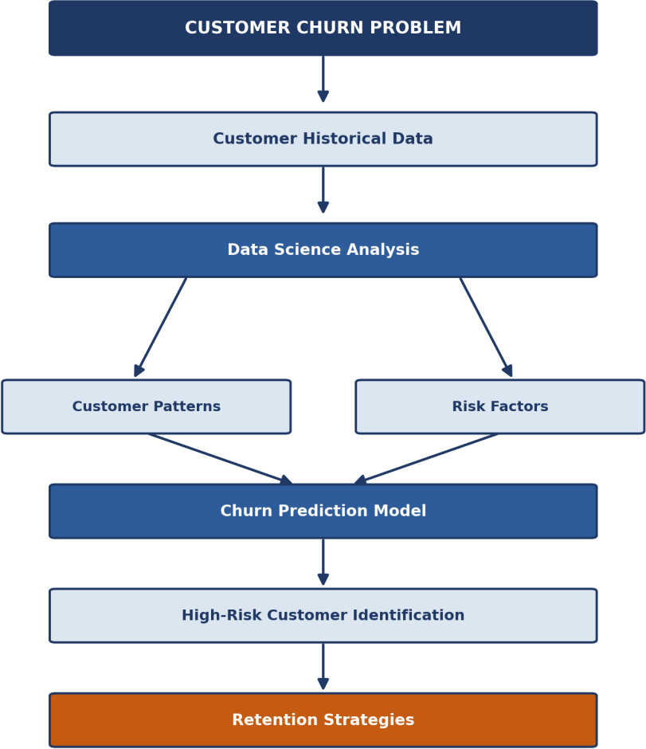

Figure 1.1 — From the customer churn problem to actionable retention strategies

Project Objectives & Scope

Objectives
    - Define a clear, hypothetical Data Science problem centered on customer churn.
    - Design a complete, structured project plan covering the full Data Science lifecycle.
    - Propose a methodology for data collection, cleaning, exploration, modeling, and evaluation.
    - Select appropriate Python tools and libraries for each stage of the workflow.
    - Establish a realistic timeline (30–35 hours) for carrying out the project.
    - Identify potential challenges and corresponding mitigation strategies.
    - Produce a professional, well-documented project planning report.

In-Scope
    - Planning and strategy design for a binary classification churn prediction problem.
    - Definition of a proposed data schema and candidate features.
    - Design of a proposed EDA, feature engineering, and modeling approach.
    - Design of an evaluation framework using standard classification metrics.
    - Discussion of anticipated challenges and mitigation strategies.

Out-of-Scope
    - Collection or use of an actual/real customer dataset.
    - Actual model training, tuning, or generation of performance results.
    - Deployment of the model into a production environment.
    - Building of a user-facing application or dashboard.

Project Assumptions
    - A structured, tabular customer dataset would be available in later stages of the internship.
    - The target variable (churn status) would be binary — churned vs. retained.
    - The project will be developed and documented using Python and Jupyter Notebook.
    - Any performance figures mentioned in this document are hypothetical and illustrative only.

Methodology & Strategy

Overall Methodology
The proposed Customer Churn Prediction project will follow a structured Data Science lifecycle. The methodology will begin with defining the business problem and identifying the data requirements. This will be followed by data collection, data understanding, data preprocessing, exploratory data analysis, feature engineering, machine learning model development, model evaluation, interpretation, and generation of business insights.
The overall methodology is designed to ensure that each stage produces reliable inputs for the next stage. Data quality will be assessed before modeling, exploratory analysis will be used to understand customer behavior, and multiple machine learning algorithms will be compared using appropriate validation and evaluation techniques.

Stage 1 — Problem Definition
The first stage is to clearly define the business and analytical problem.
How can a business identify customers who are at a high risk of churning so that appropriate retention strategies can be considered?
The corresponding machine learning problem is a binary classification problem, where each customer will be classified into one of two possible categories:
    - 0 — Customer is likely to remain
    - 1 — Customer is likely to churn

Key Activities
    - Define customer churn.
    - Identify the prediction target.
    - Determine the expected business use of predictions.
    - Identify relevant customer attributes.
    - Define project boundaries and assumptions.
    - Establish evaluation criteria.

Stage 2 — Data Collection
Since this is a hypothetical project, the report will assume that a structured customer dataset is available. Potential data sources may include:
    - Customer subscription records
    - Billing and payment records
    - Customer service interactions
    - Product/service usage records
    - Customer demographic information
    - Contract information

Potential Variables

Category | Example Variables
Customer Information | Customer ID, age group, location category
Subscription | Plan type, contract type, tenure
Financial | Monthly charges, total charges
Usage | Usage frequency, service usage
Support | Number of support requests
Payment | Payment method, payment frequency
Target | Churn status

The Customer ID would primarily serve as an identifier and would not normally be used as a predictive feature.

Stage 3 — Data Understanding
Before performing transformations, the dataset must be examined to understand its structure and quality.

Proposed Activities
- Inspect dataset dimensions.
- Identify numerical and categorical variables.
- Examine the target variable.
- Check data types.
- Calculate summary statistics.
- Identify missing values.
- Detect duplicate records.
- Examine unique values.
- Identify inconsistent categorical values.
- Analyze the distribution of the churn target.

Stage 4 — Data Cleaning & Preprocessing
Data preprocessing will prepare the hypothetical dataset for exploratory analysis and machine learning.

Missing Values
    - Numerical variables → median or appropriate statistical imputation
    - Categorical variables → mode or an explicit "Unknown" category
    - Variables with excessive missingness → consideration for removal

Duplicate Records
Duplicate customer records will be identified using appropriate identifiers and relevant attribute combinations, and removed or resolved where appropriate.

Categorical Encoding & Outlier Handling
    - Categorical features will be transformed using one-hot or ordinal encoding, as appropriate.
    - Numerical variables will be examined using statistical methods and box plots.
    - Outliers will not automatically be removed, since unusual customers may contain valuable information.

Stage 5 — Exploratory Data Analysis
EDA will be used to understand customer behavior and identify relationships between variables and churn, across three levels:

Univariate Analysis
    - Distribution of customer tenure
    - Distribution of monthly charges
    - Frequency of different contract types

Bivariate Analysis
    - Contract type vs. churn
    - Monthly charges vs. churn
    - Tenure vs. churn
    - Payment method vs. churn

Multivariate Analysis
    - Correlation heatmaps and grouped comparisons to identify patterns that inform feature engineering and modeling.

Stage 6 — Feature Engineering & Selection
    - Customer tenure groups (new / short-term / long-term customers)
    - Average usage measures, where historical usage data is available
    - Support interaction indicators (e.g. number of support requests, high-contact flag)
    - Charge-related ratios or normalized measures
Feature engineering will be performed carefully to avoid data leakage — information that would not have been available at prediction time will not be used to construct predictive features. Feature selection will then consider correlation analysis, domain relevance, feature importance, and redundancy; identifier fields such as Customer ID will be excluded from model training.

Stage 7 — Train-Test Split
The prepared dataset will be divided using an 80% training / 20% testing split. Because churn prediction is a classification problem, stratified splitting will be considered to maintain the proportion of churn and non-churn customers across subsets. The test set will remain isolated until final model evaluation.

Stage 8 — Model Development
Multiple classification algorithms will be considered rather than immediately selecting one model:

Model | Why It Is Being Considered
Logistic Regression | Simple, fast, interpretable baseline for binary classification
Decision Tree | Easy to interpret; captures rule-based, nonlinear relationships
Random Forest | Strong ensemble baseline; robust to overfitting; gives feature importance
Gradient Boosting | Boosting-based approach able to capture complex structured-data patterns

Stage 9 — Model Validation & Hyperparameter Tuning
Model performance should not be judged from a single training/testing split alone. The proposed strategy will use cross-validation, particularly during model selection and hyperparameter tuning. Potential hyperparameters may include the number of trees, maximum tree depth, minimum samples per split, learning rate, and number of boosting iterations — the exact parameters will depend on the selected algorithm.

Stage 10 — Model Evaluation
Since customer churn datasets can potentially contain imbalanced classes, accuracy alone will not be considered sufficient. The proposed evaluation metrics are:
    - Accuracy — overall proportion of correctly classified customers
    - Precision — how many customers predicted as churners are actually churners
    - Recall — how many actual churners were correctly identified
    - F1-score — balance between precision and recall
    - ROC-AUC — ability to distinguish churn vs. non-churn across thresholds
    - Confusion Matrix — true/false positives and negatives
For this project, F1-score and ROC-AUC will receive particular attention, while precision and recall will also be analyzed because false negatives may represent customers who churn but were not identified by the model.

Stage 11 — Model Interpretation
After selecting a suitable model, its predictions should be interpretable enough to support business decision-making. The analysis may consider feature importance, model coefficients for interpretable models, comparison of churn rates across important customer segments, and error analysis (false positives and false negatives). The objective is not simply to predict churn, but also to understand why certain customers are predicted to be at higher risk.

Stage 12 — Business Insights
The final analytical stage will translate model findings into business-oriented insights. Hypothetical analysis may reveal that certain customer groups have a higher predicted churn risk due to combinations of short tenure, higher monthly charges, certain contract types, frequent support interactions, or low service engagement. These findings could potentially support strategies such as targeted retention communication, improved onboarding,

proactive support, personalized service plans, and targeted retention offers. These are potential strategies, not claims about actual results.

Stage 13 — Documentation & Reproducibility
The complete project should be documented so that another analyst could understand and reproduce the workflow, including project objectives, a data dictionary, preprocessing decisions, EDA findings, feature engineering decisions, model configurations, evaluation methodology, final model selection criteria, business insights, and limitations. Python scripts and notebooks will be organized logically, with the project maintained through GitHub.

Proposed End-to-End Methodology

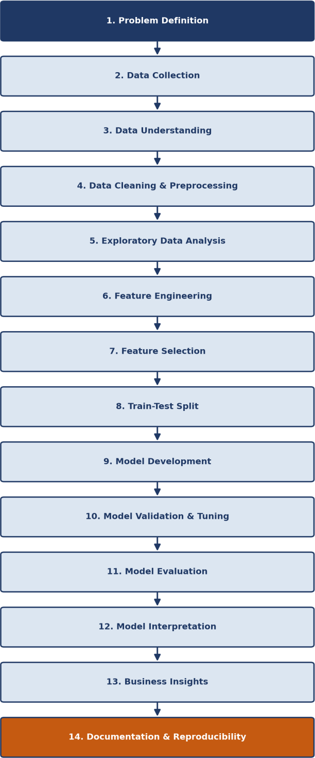

Figure 3.1 — Complete 14-stage proposed Data Science methodology

Methodology Strategy Principles
    - Data Quality First — model performance depends heavily on the quality and relevance of input data.
    - Exploratory Before Predictive — EDA will be conducted before model development.
    - Multiple Models — several candidate algorithms will be compared rather than assuming one is optimal.

    - Metric-Aware Evaluation — performance will be assessed using multiple metrics, particularly F1-score, recall, and ROC-AUC.
    - Leakage Prevention — information unavailable at prediction time will not be used to construct features.
    - Business Interpretability — the analysis should explain meaningful churn factors, not just produce predictions.
    - Reproducibility — the workflow, preprocessing, model configurations, and evaluation will be documented.

Timeline & Tools

Project Timeline — 33 Hours
The Week 1 task requires a timeline allocating approximately 30–35 hours. This project uses 33 hours, distributed across the full Data Science lifecycle rather than concentrated on documentation alone.

Phase | Activities | Hours
1. Problem Definition | Business problem, objectives, scope and assumptions | 2
2. Data Collection & Understanding | Identify data sources, variables, target, data types and quality requirements | 4
3. Data Cleaning & Preprocessing | Missing values, duplicates, encoding, outliers and data validation | 5
4. Exploratory Data Analysis | Univariate, bivariate and multivariate analysis | 5
5. Feature Engineering & Selection | Create, transform and select predictive features | 3
6. Model Development | Train and compare candidate classification models | 5
7. Model Validation & Evaluation | Cross-validation, hyperparameter tuning and performance evaluation | 4
8. Interpretation & Business Insights | Feature importance, error analysis and retention insights | 2
9. Documentation & Presentation | Report preparation, diagrams, workflow documentation and final review | 3
Total |  | 33 Hours

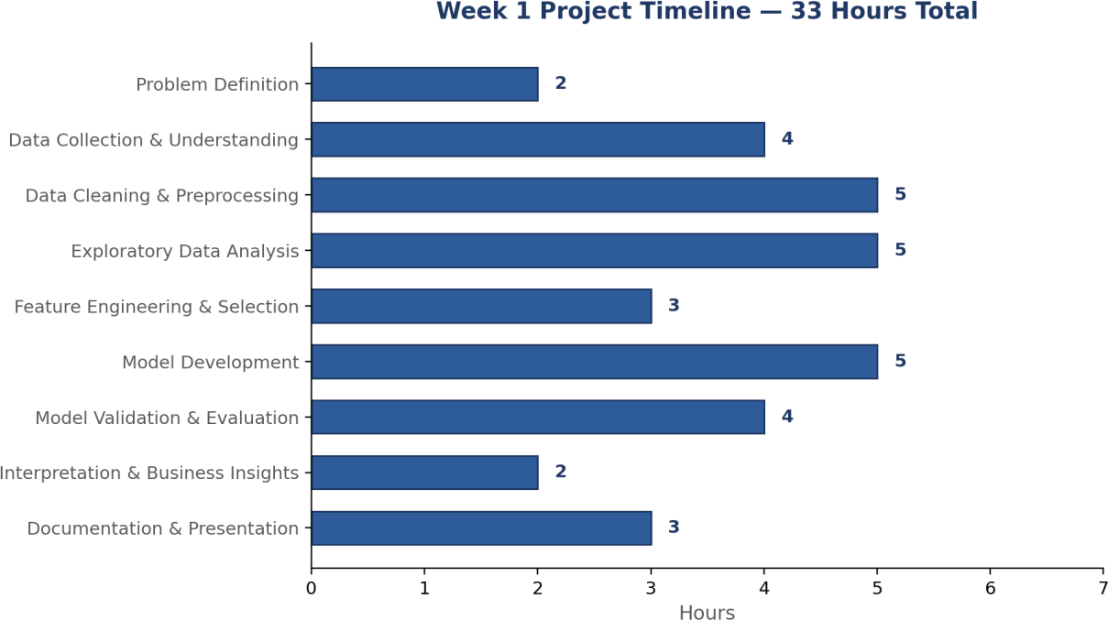

Figure 4.1 — Distribution of the 33-hour timeline across project phases

Timeline Strategy
    - Data First — 16 hours allocated to problem definition, data understanding, preprocessing, EDA, and feature engineering.
    - Modeling Second — 9 hours allocated to model development, validation, and evaluation.
    - Interpretation & Communication — 5 hours allocated to interpreting results and preparing documentation. This reflects the fact that a successful Data Science project is not simply about training a model — data quality, exploratory analysis, validation, and communication are equally important.

Programming Language
Python will be the primary programming language, as it provides a comprehensive ecosystem for data manipulation, statistical analysis, visualization, machine learning, and project development.

Python Libraries

Library | Purpose
Pandas | Data manipulation and analysis — loading, cleaning, transforming, grouping data
NumPy | Numerical computing — array operations and mathematical calculations
Matplotlib | Fundamental data visualization — histograms, bar charts, line/scatter plots
Seaborn | Statistical data visualization — distribution plots, box plots, correlation heatmaps
Plotly | Interactive visualization for exploratory charts and presentation-oriented views

Scikit-learn | Machine learning — preprocessing, train-test split, classification models, cross-validation, metrics

Development & Project Management Tools
    - Jupyter Notebook — interactive development combining code, outputs, visualizations, and explanations.
    - Git — version control for scripts, notebooks, documentation, and configuration files.
    - GitHub — remote repository for code, documentation, and notebooks; a GitHub URL is compulsory for technical/software internships.

Tool-to-Stage Mapping
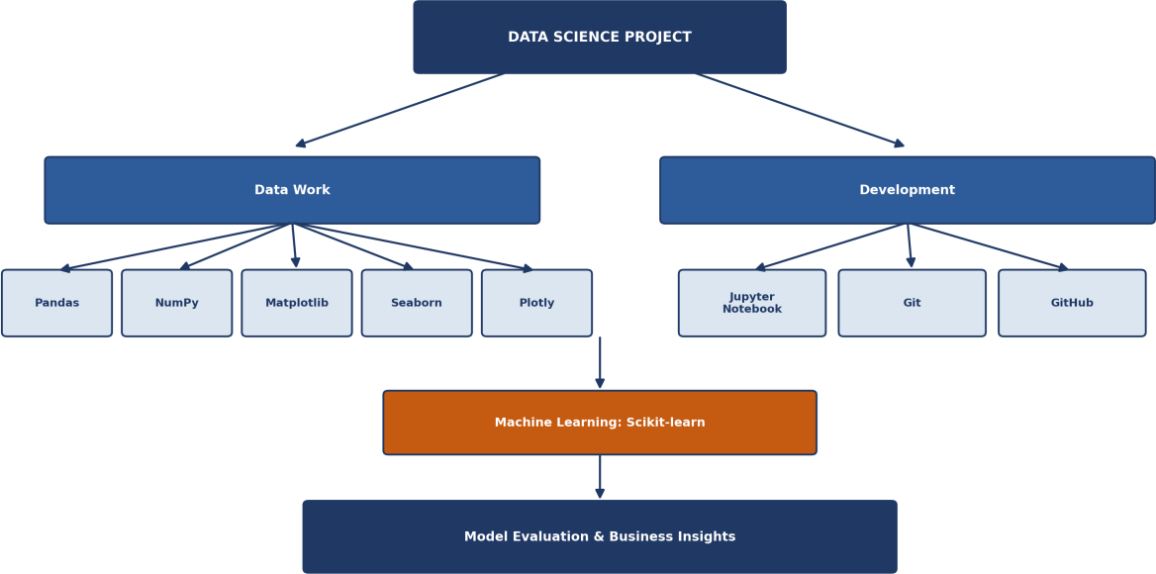

Figure 4.2 — Mapping of tools to the stages of the Data Science workflow

TensorFlow, PyTorch, Flask, Docker, and cloud deployment services are intentionally not included, since this is a tabular binary-classification problem and the Week 1 task does not require deployment. Keeping the technology stack focused is a stronger project-planning decision than listing unnecessary technologies.

Expected Outcomes & Challenges
This section is intentionally hypothetical, since no actual dataset or model execution is required in Week 1.

Expected Outcomes

Structured Customer Data Pipeline
A well-defined data pipeline will be established for collecting, understanding, cleaning, transforming, and preparing customer data — handling missing values, duplicate records, inconsistent data, categorical and numerical variables, outliers, and feature transformations.

Identification of Customer Churn Patterns
EDA is expected to reveal relationships between customer characteristics (tenure, contract type, monthly charges, service usage, payment method, support interactions) and churn behavior, establishing which characteristics deserve greater attention during modeling.

Machine Learning Classification Framework
A machine learning pipeline capable of classifying customers by predicted churn status, comparing Logistic Regression, Decision Tree, Random Forest, and Gradient Boosting, with the final model chosen based on comparative evaluation rather than assumption.

Model Evaluation Framework
A comprehensive evaluation strategy using accuracy, precision, recall, F1-score, ROC-AUC, confusion matrix, and cross-validation — with particular attention to recall and F1-score, since failing to identify a customer who subsequently churns may be more costly than incorrectly flagging a low-risk customer.

Identification of Important Churn Factors
Analysis expected to identify which customer attributes have the strongest relationship with churn predictions
— bridging technical modeling and business decision-making.

Data-Driven Retention Insights
A framework for converting analytical findings into potential retention strategies. These would be potential recommendations based on hypothetical analysis, not confirmed business findings.

Reproducible Data Science Workflow
A clearly documented, reproducible workflow (Data → Preprocessing → EDA → Feature Engineering → Modeling → Evaluation → Interpretation → Business Insights) that can serve as a foundation for future implementation using a real dataset.

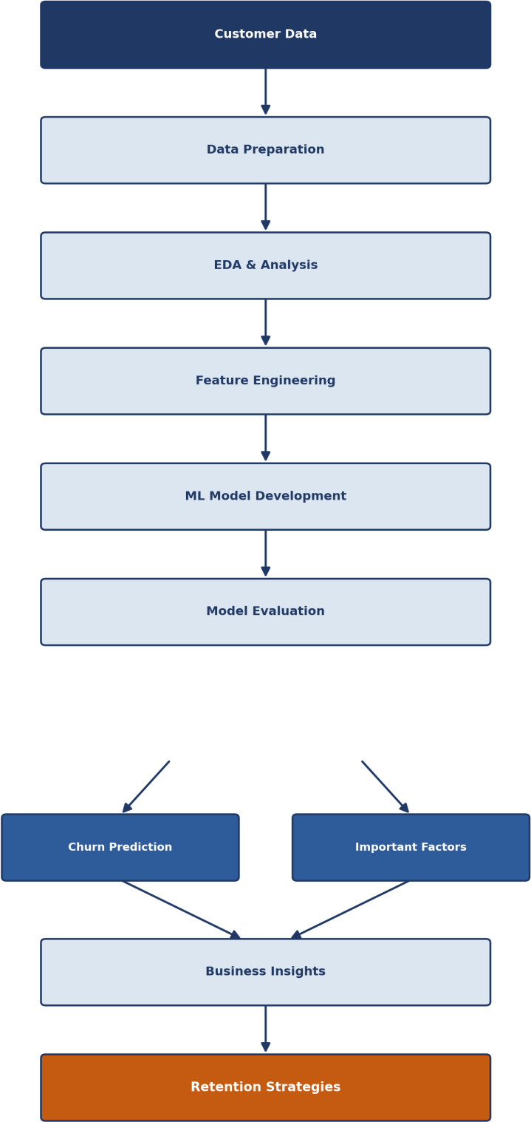

Figure 5.1 — Expected outcome flow, from customer data to retention strategy

Expected Benefits

Business Benefits
    - Earlier identification of potentially high-risk customers
    - Better understanding of customer behavior

    - Support for targeted retention strategies
    - More informed customer-management decisions
    - Potential reduction in avoidable customer loss

Technical Benefits
    - Demonstrates an end-to-end Data Science workflow
    - Provides experience with structured/tabular data
    - Applies Python-based data analysis and classification modeling
    - Introduces model validation, evaluation, and interpretable analysis

Strategic Benefit
The project demonstrates how organizations can move from reactive customer management to predictive customer management, by using historical data to anticipate potential customer churn.

Anticipated Challenges & Mitigation

Challenge | Potential Impact | Mitigation Strategy
Missing Data | Reduced data quality | Imputation and missingness analysis
Class Imbalance | Poor minority-class detection | Stratification, class weighting and suitable metrics
Outliers | Distorted analysis/model | Investigation and appropriate treatment
Irrelevant Features | Increased complexity | Feature selection
Data Leakage | Unrealistic model performance | Strict train/test separation and pipeline design
Overfitting | Poor generalization | Cross-validation and regularization
Poor Interpretability | Difficult business adoption | Feature importance and interpretable models
Data Drift | Reduced future performance | Monitoring and periodic retraining

Project Limitations
- The project is initially hypothetical and therefore does not establish real-world model performance.
- The quality of predictions will depend on the availability and quality of historical customer data.
- Customer churn can be influenced by factors that may not be captured in structured datasets.
- Correlation between customer characteristics and churn does not necessarily establish causation.
- A predictive model can identify risk but cannot guarantee that a customer will churn.
- Retention strategies would need to be evaluated separately to determine their actual business effectiveness.

This project will not claim that the proposed model will automatically reduce churn — its purpose is to establish a sound analytical framework.

Conclusion
This Week 1 report has established a complete, structured, and reproducible plan for a hypothetical Customer Churn Prediction and Retention Analysis project. The report defined the business problem and its motivation, set clear objectives and scope boundaries, proposed a detailed 14-stage Data Science methodology, allocated a realistic 33-hour timeline across a focused Python-based technology stack, and identified the outcomes, benefits, and challenges anticipated for the project.
Rather than treating each week of the internship as a separate exercise, this plan is intentionally designed to be built upon: Week 2 will expand the exploratory data analysis into a detailed visualization framework, and Week 3 will expand the preprocessing, model development, training, validation, and evaluation stages into a complete machine learning implementation plan. This ensures that the project develops as a single, consistent body of work across the internship rather than being rewritten from scratch each week.
Overall, this planning phase provides a strong analytical and organizational foundation — one that reflects sound Data Science practice by prioritizing data quality, exploratory understanding, leakage prevention, and business interpretability, well before any model is trained.

References & Tools Summary

Proposed Technology Stack

Category | Technology | Purpose
Programming | Python | Primary development language
Data Manipulation | Pandas | Data cleaning and analysis
Numerical Computing | NumPy | Numerical operations
Visualization | Matplotlib | Basic statistical charts
Visualization | Seaborn | Statistical visualization
Interactive Visualization | Plotly | Interactive charts
Machine Learning | Scikit-learn | Model development and evaluation
Development | Jupyter Notebook | Interactive analysis
Version Control | Git | Version tracking
Repository | GitHub | Code and project management

Documentation Reference
    - Pandas Documentation — pandas.pydata.org
    - NumPy Documentation — numpy.org
    - Matplotlib Documentation — matplotlib.org
    - Seaborn Documentation — seaborn.pydata.org
    - Plotly Documentation — plotly.com/python
    - Scikit-learn Documentation — scikit-learn.org
    - Project GitHub Repository — churn-prediction-project (see repository README for structure and setup instructions)

